**Sponsorship Agreement**

**between**

**ICSOBA and XXXX**

**ICSOBA Board cordially invites you to become**

**SPONSOR**

**of the 38th International Conference and Exhibition**

**in**

**Jinan, Shandong province, China**

**12 – 16 October 2020**

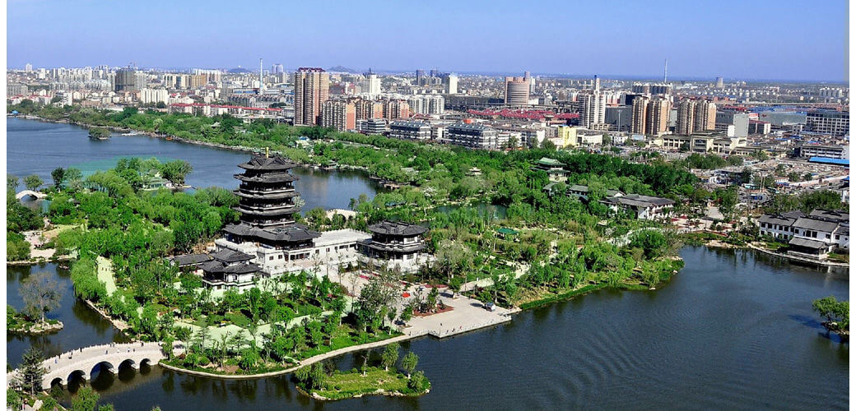

Welcome to the

38th Conference and Exhibition

ICSOBA 2020

12th – 16th October 2020, Jinan, China

In collaboration with SUNSTONE

*Your sponsorship benefits are described in an attached document*

**Sponsorship administration:**

|  |  |  |  |  |  |  |  |  |  |  |  |  |  |
| --- | --- | --- | --- | --- | --- | --- | --- | --- | --- | --- | --- | --- | --- |
| |  | | --- | | Signature of agreement: | | Name: | | Job Title: | | Date: | | Email: | | Tel. Number: | | |  | | --- | | Please fill in as you would like to appear on the invoice:  Company Name: | | Invoice Address: | |  | |  | |  | | VAT Number: | |

|  |
| --- |
| **INVOICING METHODS**  Could you please specify if:  🞐 You elect to send a Purchase Order to ICSOBA. In such case, we will send our invoice according to your purchase order.  🞐 You elect to directly receive our invoice for processing your payment |

**Please sign, complete and return this form to:**

**Frank R. Feret**

Vice Chairman, Chief Executive Officer

[www.ICSOBA.org](http://www.icsoba.org/)

[frank.feret@icsoba.org](mailto:frank.feret@icsoba.org)

|  |
| --- |
| **PAYMENT METHODS**  **Credit Card** payment, using the secure online payment service **"Stripe"**  **PayPal** payment by credit card (no need for PayPal account)  **Wire transfer** to the Bank of Montreal, Canada  Detailed payment instruction will be provided with your Sponsorship invoice. |